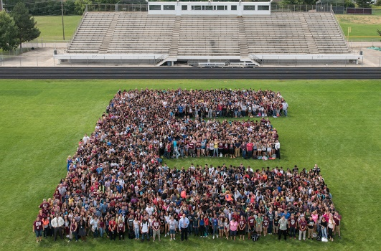

**Level Up**

**Try Everything**

**Give Grace**

**Earn and give respect**

**Hold yourself responsible  
Safety first**

Elgin High School Student Bulletin

Wednesday May 7th 2025

* 5/7 (Main Office) Students, Wednesday’s alphabet countdown is L for Lollapalooza! Wear your favorite concert outfit or band tee!
* 5/7 (Main Office) SENIORS! If you have not picked up your cap and gown PLEASE stop by the main office and do so.
* 5/7 (Ryan) Any student who was invited to the dia de logros last week, and did NOT attend the event can pick up their stole in the main office during lunch periods or before or after school this week. Students who earned a medal for academic excellence will need to contact Mrs. Ryan directly to schedule a time to pick up your medal. If you have any questions please see Mrs. Ryan in 115 or by emailing [veronicaryan@u-46.org](mailto:veronicaryan@u-46.org)
* 5/7 (Gallegos) EHS Cheer Open Gym will be May 6th from 4-6pm and May 7th from 4:30-6:30pm in the fieldhouse. Open gyms are great opportunities to practice your jumping, tumbling, stunting, and cheer skills prior to tryouts, and all are welcome. Follow our instagram @elgincheerleading and @elginjvcheerleading for more information.